MM19B012_Question-3
Detecting lines in an image is important for a whole bunch of people. Metallurgists look for these inkikuchi diffraction patterns to index the orientation of crystals. Computer vision chaps look for it to identify straight edges of the shape being imaged for feature detection. Transport folk look for the lanes to help the autonomous car drive along looking at the road.

Answer:-
The Problem requires us to do two things
- render only the outlines and
- detect those which form a line.

The Hough Transform is a method that is used in image processing to detect any shape, if that shape can be represented in mathematical form

To use hough transform the lines of the image i.e the outline must be clearly visible. To do that we find the outline of our image in octave.
Boundaries can be found using Gradients as a sharp change in value in the image matrix signifies a boundary

Solution methodology:-
- using octave, we load images and perform our maniplations
- first we render the image grayscale and copy it into a matrix
- to find boundaries we find gradient of said matrix
- we scale the values above a certain thershold to max while those below that to zero. This is noise reduction
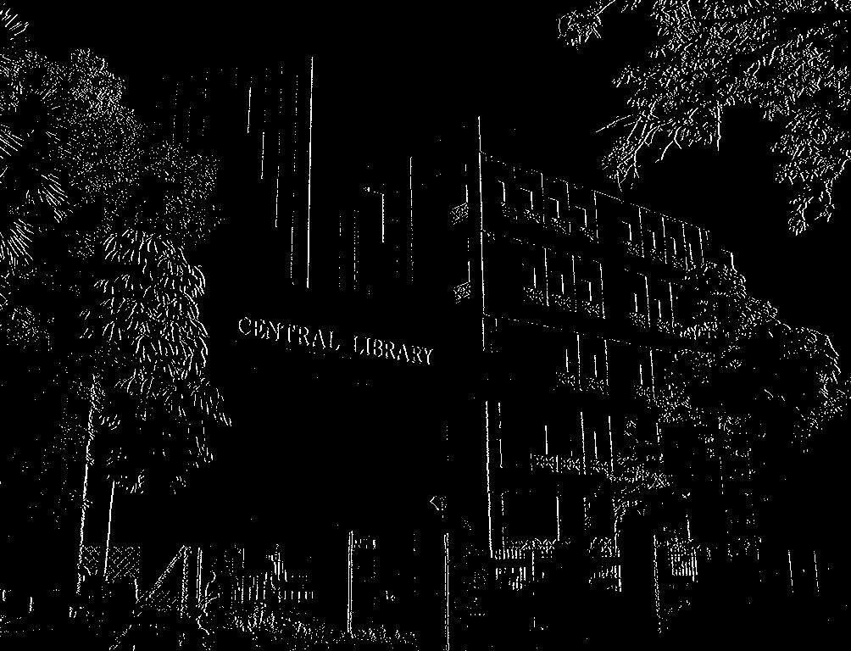
- now the image looks like this.

- Using hough transform in cv package, we optimize theta and rho (distance angle form)
- First it creates a 2D array (to hold values of two parameters) and it is set to zero initially.
Let rows denote rho and columns denote theta.

- X = rho*cos(theta), y= rho*sin(theta)
- using a voting procedure, the Hough transform recognizes points lying in such a pattern and the true cases are shown.
- The final number of lines depends on sensitivity to noise, starightness of lines and thickness of said lines

Choice of programs used:
- Octave:- I have used octave for image manipulation as ocatve can easily
      - read images and show images
      - convert images to matrices and perform operations on them
      - acess individual pixel data through said matrices for gradient and noise cancellation.
- Python:- Python is used for hough transform due to
          - easy implementation of voting procedure
          - opencv package uses hough transform
          - compatibility with images produced from ocatve

